|  |  |
| --- | --- |
| 9/8/25, 11:08 AM | Gmail - Fire Calls for Aug 2025 |
| Yd Gmail | Jason Jakobi <jjakobi69@gmail.com> |

Fire Calls for Aug 2025 

1 message

Jason Jakobi <jjakobi69@gmail.com> sun, sep 7, 2025 at 6:53 PM

To: Jim Brink <jabrink66@hotmaiI.com>

Fire calls for the month of Aug 2025,

8/15/25 #19 PI Accident on Indian Lake rd near Vaughn Rd.

8/16/25 #20 1719 Iroquois Trait Residential Fire Alarm Canceled Enroute.

8/16/25 #21 3442 Midland Street Natural Gas leak. 8/16/25 1309 Ash Street Down Power Line.

Jeff and I are both done with our Fire Officer 1 classes. Just need to do our state test.



This Saturday the 13th there will be a Drivers Training class held at our department, We have 1 attending the class.



 Hose testing has been completed and 3 2 1/2 has failed due to old age.

September 27 & 28 Fire Investigation class will be held at our department.

I also have a quote from the picture that you sent me for the Memorial wall that I will print off tomorrow and show you all.

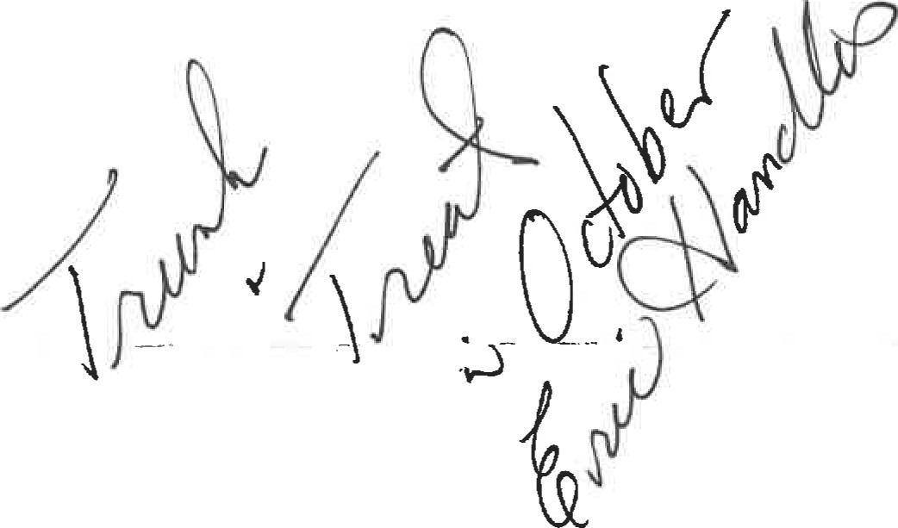See you tomorrow, 

Jason Jakobi, Assistant Fire Chief

Grant Township Fire Department

4049 Indian Lake Rd

National City, Ml 48748

Cell: (989) 984-9012

Station: (989) 469-3177 Ext. 4

https://mail.google.com/mail/u/O/?ik=ed3fb713e0&view=pt&search=all&permthid=thread-a:r-8112760381598898895&simpl=msg-a:r-24116907757777...